AI Grocery Recommender

Software Requirements Specification

Version 1.0



Submitted By:
<2024-cse-058>
< Hafiz Abdullah >

EXORDIUM

In the name of Allah, the Compassionate, the Merciful.

Praise be to Allah, Lord of Creation,
The Compassionate, the Merciful,
King of Judgment-day!

You alone we worship, and to You alone we pray for help,
Guide us to the straight path

The path of those who You have favored,

Not of those who have incurred Your wrath,
Nor of those who have gone astray.

Revision History
Date (dd/mm/yyyy) | Version | Description | Author
Current date | 1.0 | Introduction of the project | Write student(s) id

Table of Contents

- Scope (of the project)
- Functional Requirements Non-Functional requirements
- Use Case Diagram
- Usage Scenarios

SRS Document

AI Grocery Recommender Project Scope

Project Objectives
This project will develop an intelligent grocery recommendation system that personalizes shopping suggestions based on individual preferences, dietary needs, and purchase history. The system aims to enhance user experience by reducing decision fatigue, promoting healthier choices, and optimizing grocery budgets. Success will be measured through user engagement metrics, recommendation accuracy scores, and customer satisfaction surveys.

Core Features In-Scope
- User profile management with dietary preferences and restrictions
- AI-powered personalized product recommendations
- Smart shopping list generation and management
- Recipe-based meal planning with ingredient integration
- Nutritional analysis and health-conscious suggestions
- Budget optimization and cost-saving recommendations
- Integration with grocery retailer product catalogs

Key Exclusions
The project will not include payment processing systems, physical delivery logistics, inventory management for retailers, social media features, or voice assistant integration. These elements are reserved for potential future phases based on initial system performance and user feedback.

Functional Requirements

- Product Browsing & Search
  - Users can browse grocery products with pagination (25 products per page)
  - Search functionality to filter products by name
  - Display product details: name, category, price, rating, popularity
- Shopping Cart Management
  - Add products to shopping cart with one click
  - Remove individual products from cart
  - Clear all cart items at once
  - Real-time cart counter update
- Automatic AI Recommendations
  - System automatically generates recommendations when products are added to cart
  - Uses mock KNN algorithm to suggest similar products
  - Recommendations update in real-time as cart changes
- Mobile & Desktop Responsiveness
  - Responsive design adapting to mobile, tablet, and desktop screens
  - Mobile-specific UI with bottom navigation and modal dialogs
  - Touch-friendly buttons with minimum 44px target size
- Product Selection Persistence
  - Selected products persist during browsing/pagination
  - Visual indication of added products (green "Added" button)
  - Cart items visible in sidebar on desktop
- Data Management & Fallback
  - Load products from API with fallback to sample data
  - Handle API failures gracefully
  - Mock recommendation generation when API unavailable
- Statistics Display
  - Show total product count
  - Display category count
  - Show number of selected items
  - Current page information

Non-Functional Requirements
- Performance
  - Page load time under 3 seconds on average connections
  - Smooth animations and transitions (fade-in effects)
  - Debounced search input (300ms delay) to prevent excessive filtering
- Usability
  - Intuitive interface requiring minimal instructions
  - Consistent design language across all components
  - Accessible color contrast ratios (black/white theme)
  - Clear visual feedback for all interactions
- Responsiveness
  - Support for mobile devices down to 360px width
  - Adapt layout for different screen sizes (grid columns adjust)
  - Touch-friendly interface with appropriate button sizes
- Reliability
  - Graceful degradation when API unavailable
  - No application crashes on network errors
  - Data persistence during session
  - Stable pagination handling
- Scalability
  - Can handle up to 100+ products without performance degradation
  - Efficient pagination to manage large product catalogs
  - Lightweight mock algorithms for demonstration
- Maintainability
  - Well-structured, commented JavaScript code
  - Modular CSS with CSS custom properties (variables)
  - Separation of concerns (HTML/CSS/JS in single file but organized)
  - Consistent naming conventions
- Cross-Browser Compatibility
  - Support for modern browsers (Chrome, Firefox, Safari, Edge)
  - iOS Safari safe area support
  - Mobile viewport optimization

Use Case Diagram(s):

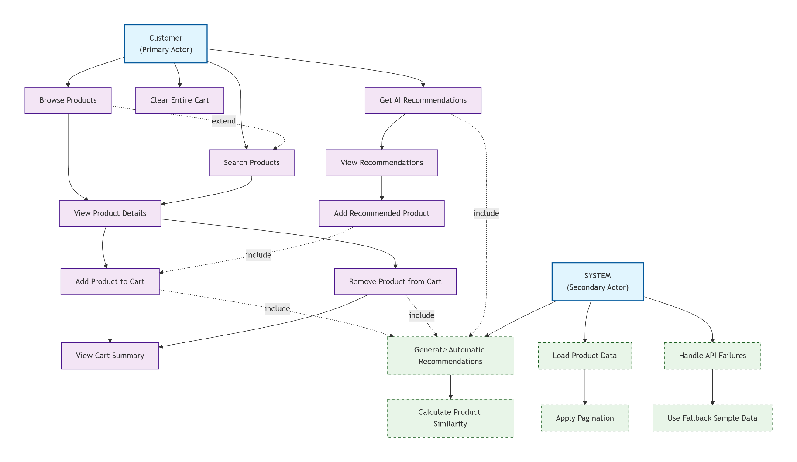

Use Case Sanerio

1. Browse Products
- ID: UC-001
- Actor: Customer
- Description: Customer views available grocery products
- Preconditions: Application loaded, products available
- Main Flow:
  - System displays products in grid format
  - System shows pagination controls
  - Customer navigates through product pages
  - System updates display with current page products
- Extensions:
  - 2a: Less than 25 products → Hide pagination
  - 3a: Customer searches → UC-002 (Search Products)

2. Search Products
- ID: UC-002
- Actor: Customer
- Description: Customer searches for specific products
- Preconditions: Application loaded
- Main Flow:
  - Customer enters search term
  - System filters products in real-time (debounced)
  - System updates product display
- Postconditions: Filtered products shown

3. View Product Details
- ID: UC-003
- Actor: Customer
- Description: Customer views detailed information about a product
- Preconditions: Products loaded
- Main Flow:
  - Customer views product card showing:
    - Product name
    - Category with badge
    - Price
    - Star rating
    - Popularity indicator
    - Product ID
  - Customer sees "Add to Cart" button

4. Add Product to Cart
- ID: UC-004
- Actor: Customer
- Description: Customer adds a product to shopping cart
- Preconditions: Product available, cart not full (no limit)
- Main Flow:
  - Customer clicks "Add to Cart" button
  - System adds product to selected items list
  - System updates cart counter
  - System changes button to "Added" (green)
  - System shows success toast notification
  - <Include> UC-009 (Generate Automatic Recommendations)
- Postconditions: Product in cart, recommendations generated

5. Remove Product from Cart
- ID: UC-005
- Actor: Customer
- Description: Customer removes product from cart
- Preconditions: Product in cart
- Main Flow:
  - Customer clicks "×" button in cart list
  - System removes product from selected items
  - System updates cart counter
  - System changes product button back to "Add to Cart"
  - System shows warning toast notification
  - <Include> UC-009 (Generate Automatic Recommendations)

6. Clear Entire Cart
- ID: UC-006
- Actor: Customer
- Description: Customer removes all products from cart
- Preconditions: At least one product in cart
- Main Flow:
  - Customer clicks "Clear All" button
  - System removes all products from selected items
  - System resets cart counter to 0
  - System resets all "Add to Cart" buttons
  - System shows info toast notification
  - System clears recommendations

7. View Cart Summary
- ID: UC-007
- Actor: Customer
- Description: Customer views selected products
- Main Flow:
  - Desktop: Cart always visible in sidebar
  - Mobile: Customer opens cart modal
  - System displays:
    - Product name with icon
    - Price
    - Remove button for each item

8. Get AI Recommendations
- ID: UC-008
- Actor: Customer
- Description: Customer manually requests recommendations
- Preconditions: At least one product in cart
- Main Flow:
  - Customer clicks "Get AI Recommendations" button
  - System generates recommendations
  - System displays recommendations panel
- Extensions:
  - 1a: Empty cart → Button disabled, show warning toast

9. Generate Automatic Recommendations (System)
- ID: UC-009
- Actor: System
- Trigger: Product added/removed from cart
- Description: System automatically generates recommendations
- Main Flow:
  - System detects cart change
  - System calculates product similarities using mock KNN
  - System filters out already selected products
  - System scores remaining products (0-100%)
  - System displays top 5 recommendations
- Business Rules:
  - Only products with >30% similarity shown
  - Throttled to max 1 request per second

10. Add Recommended Product to Cart
- ID: UC-010
- Actor: Customer
- Description: Customer adds recommended product to cart
- Main Flow:
  - Customer clicks "Add" button on recommendation
  - <Include> UC-004 (Add Product to Cart)
  - System disables add button on that recommendation
  - System re-generates recommendations

11. View Recommendations
- ID: UC-011
- Actor: Customer
- Description: Customer views AI-generated recommendations
- Main Flow:
  - Desktop: Always visible in right sidebar
  - Mobile: Opens modal with recommendations
  - Each recommendation shows:
    - Product name and category
    - Similarity score (percentage)
    - Price and rating
    - Add button

12. Load Product Data (System)
- ID: UC-012
- Actor: System
- Description: System loads product information
- Main Flow:
  - System attempts to fetch from API
  - If successful, use API data
  - If fails, use sample data
  - System displays loading spinner
  - System populates product grid

13. Handle API Failures (System)
- ID: UC-013
- Actor: System
- Description: System handles API communication failures
- Main Flow:
  - System detects API failure
  - <Include> UC-014 (Use Fallback Sample Data)
  - System shows demo mode notification
  - System continues functioning with mock data

14. Use Fallback Sample Data (System)
- ID: UC-014
- Actor: System
- Description: System uses pre-defined sample data
- Main Flow:
  - System generates 100 sample products
  - System creates 10 sample categories
  - System populates interface with mock data
  - System enables mock recommendation algorithm

Entity Relationship Diagram
